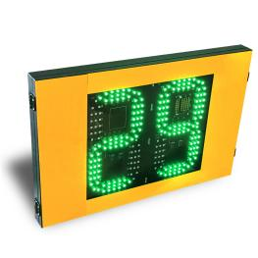
888 Radar Speed Sign User Manual
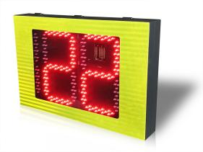
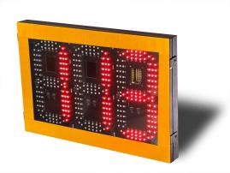

1. Introduction: In order to enhance driver safety awareness, prevent speeding, and promote slowing down while approaching curves, the speed sign also serves to alert vehicles in the opposite lane to pay attention to oncoming traffic when entering curves.
Working principle: Utilizing millimeter-wave radar as the detection source (emitting electromagnetic waves), when a moving vehicle is detected passing through, the radar sends a signal to the control board. The control board performs precise calculations to determine the current vehicle speed and displays it. If the speed does not exceed the set limit, it is displayed in green. If it exceeds the set limit, it is displayed in red, indicating the vehicle is speeding and should slow down.
- Parameters
Working Voltage | DC24V
Power | MAX 36W
LED Quantities | 585PCS
LED Model | SMD5050
Modulation Method | W Waveform detects moving vehicles, with a detection range of ≥150 meters
Speed Measurement Range | 1KM/H~250KM/H
Speed Measurement Error | <±1KM/H
Parameter setting | Phone APP
Radar Installation | Integrated Radar
Waterproof Level | IP54
Working Temperature | -40-60℃
Installation | Bracket
- Product dimensions：
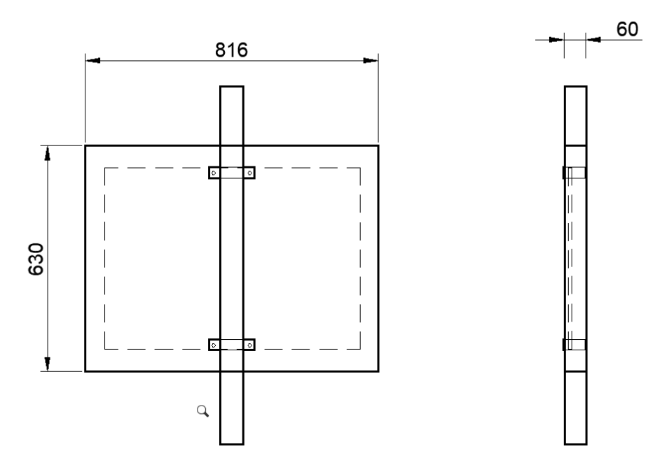
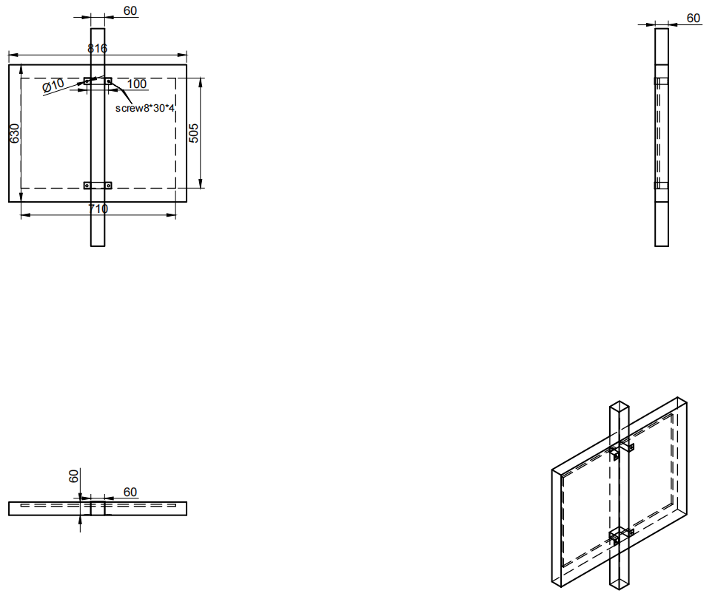
4Installation diagram：

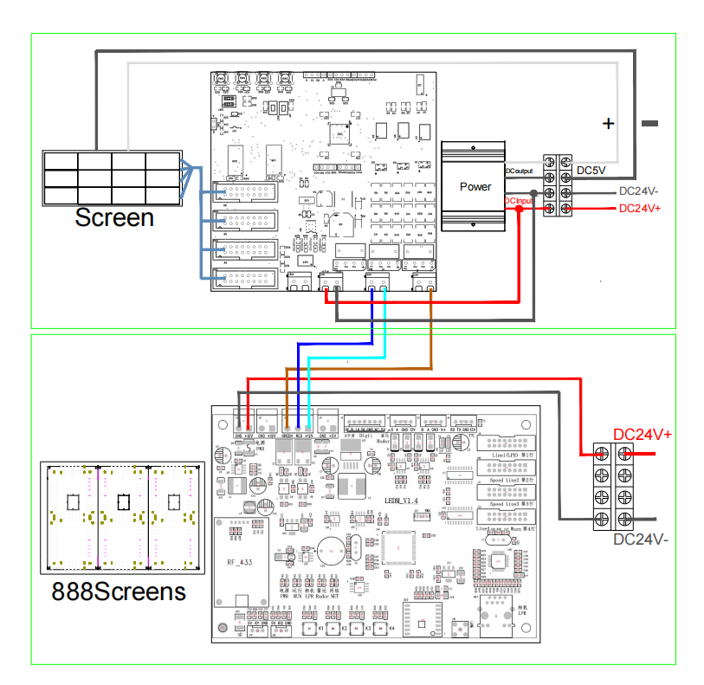
Wiring diagram：

